Software Development Unit 3, 4.6

Anna Legaspi

# I can assess when there is a problem with collaborative technologies and when to get expert help

My approach to an issue is dependent on the problem. For example, I could have problems with the software, hardware, connectors, power, OS, etc. I have a set of steps I would check firstly to try and diagnose the problem. In this example, I will demonstrate checking MS Teams to work with my laptop and have a successful meeting.

1. Check that all hardware is plugged and that appropriate connectors are used as per manufacturer’s instructions.
2. Check that all hardware is not broken and in good working order.
3. Check that all hardware is powered sufficiently
4. Check if the minimum requirements are compatible between the software and hardware.

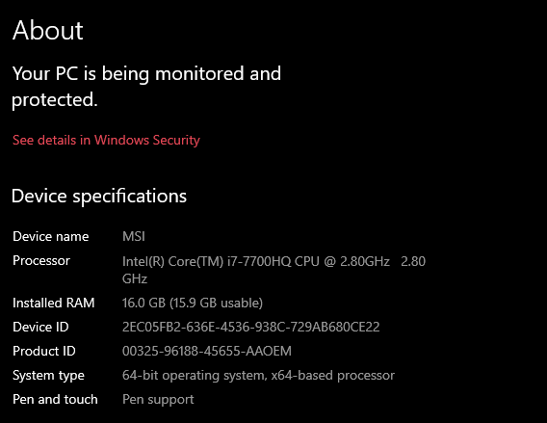

1. Check that the software is compatible with the Operating System

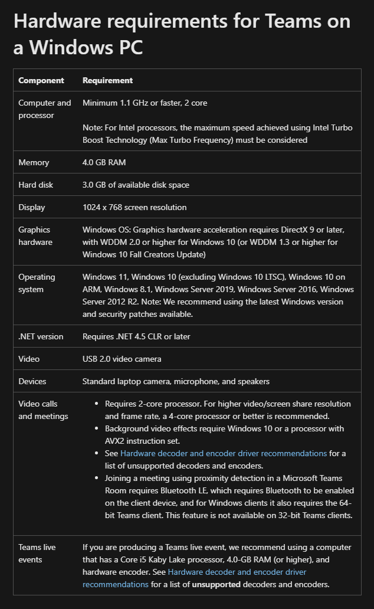

1. Check if I have the most up to date version of the software

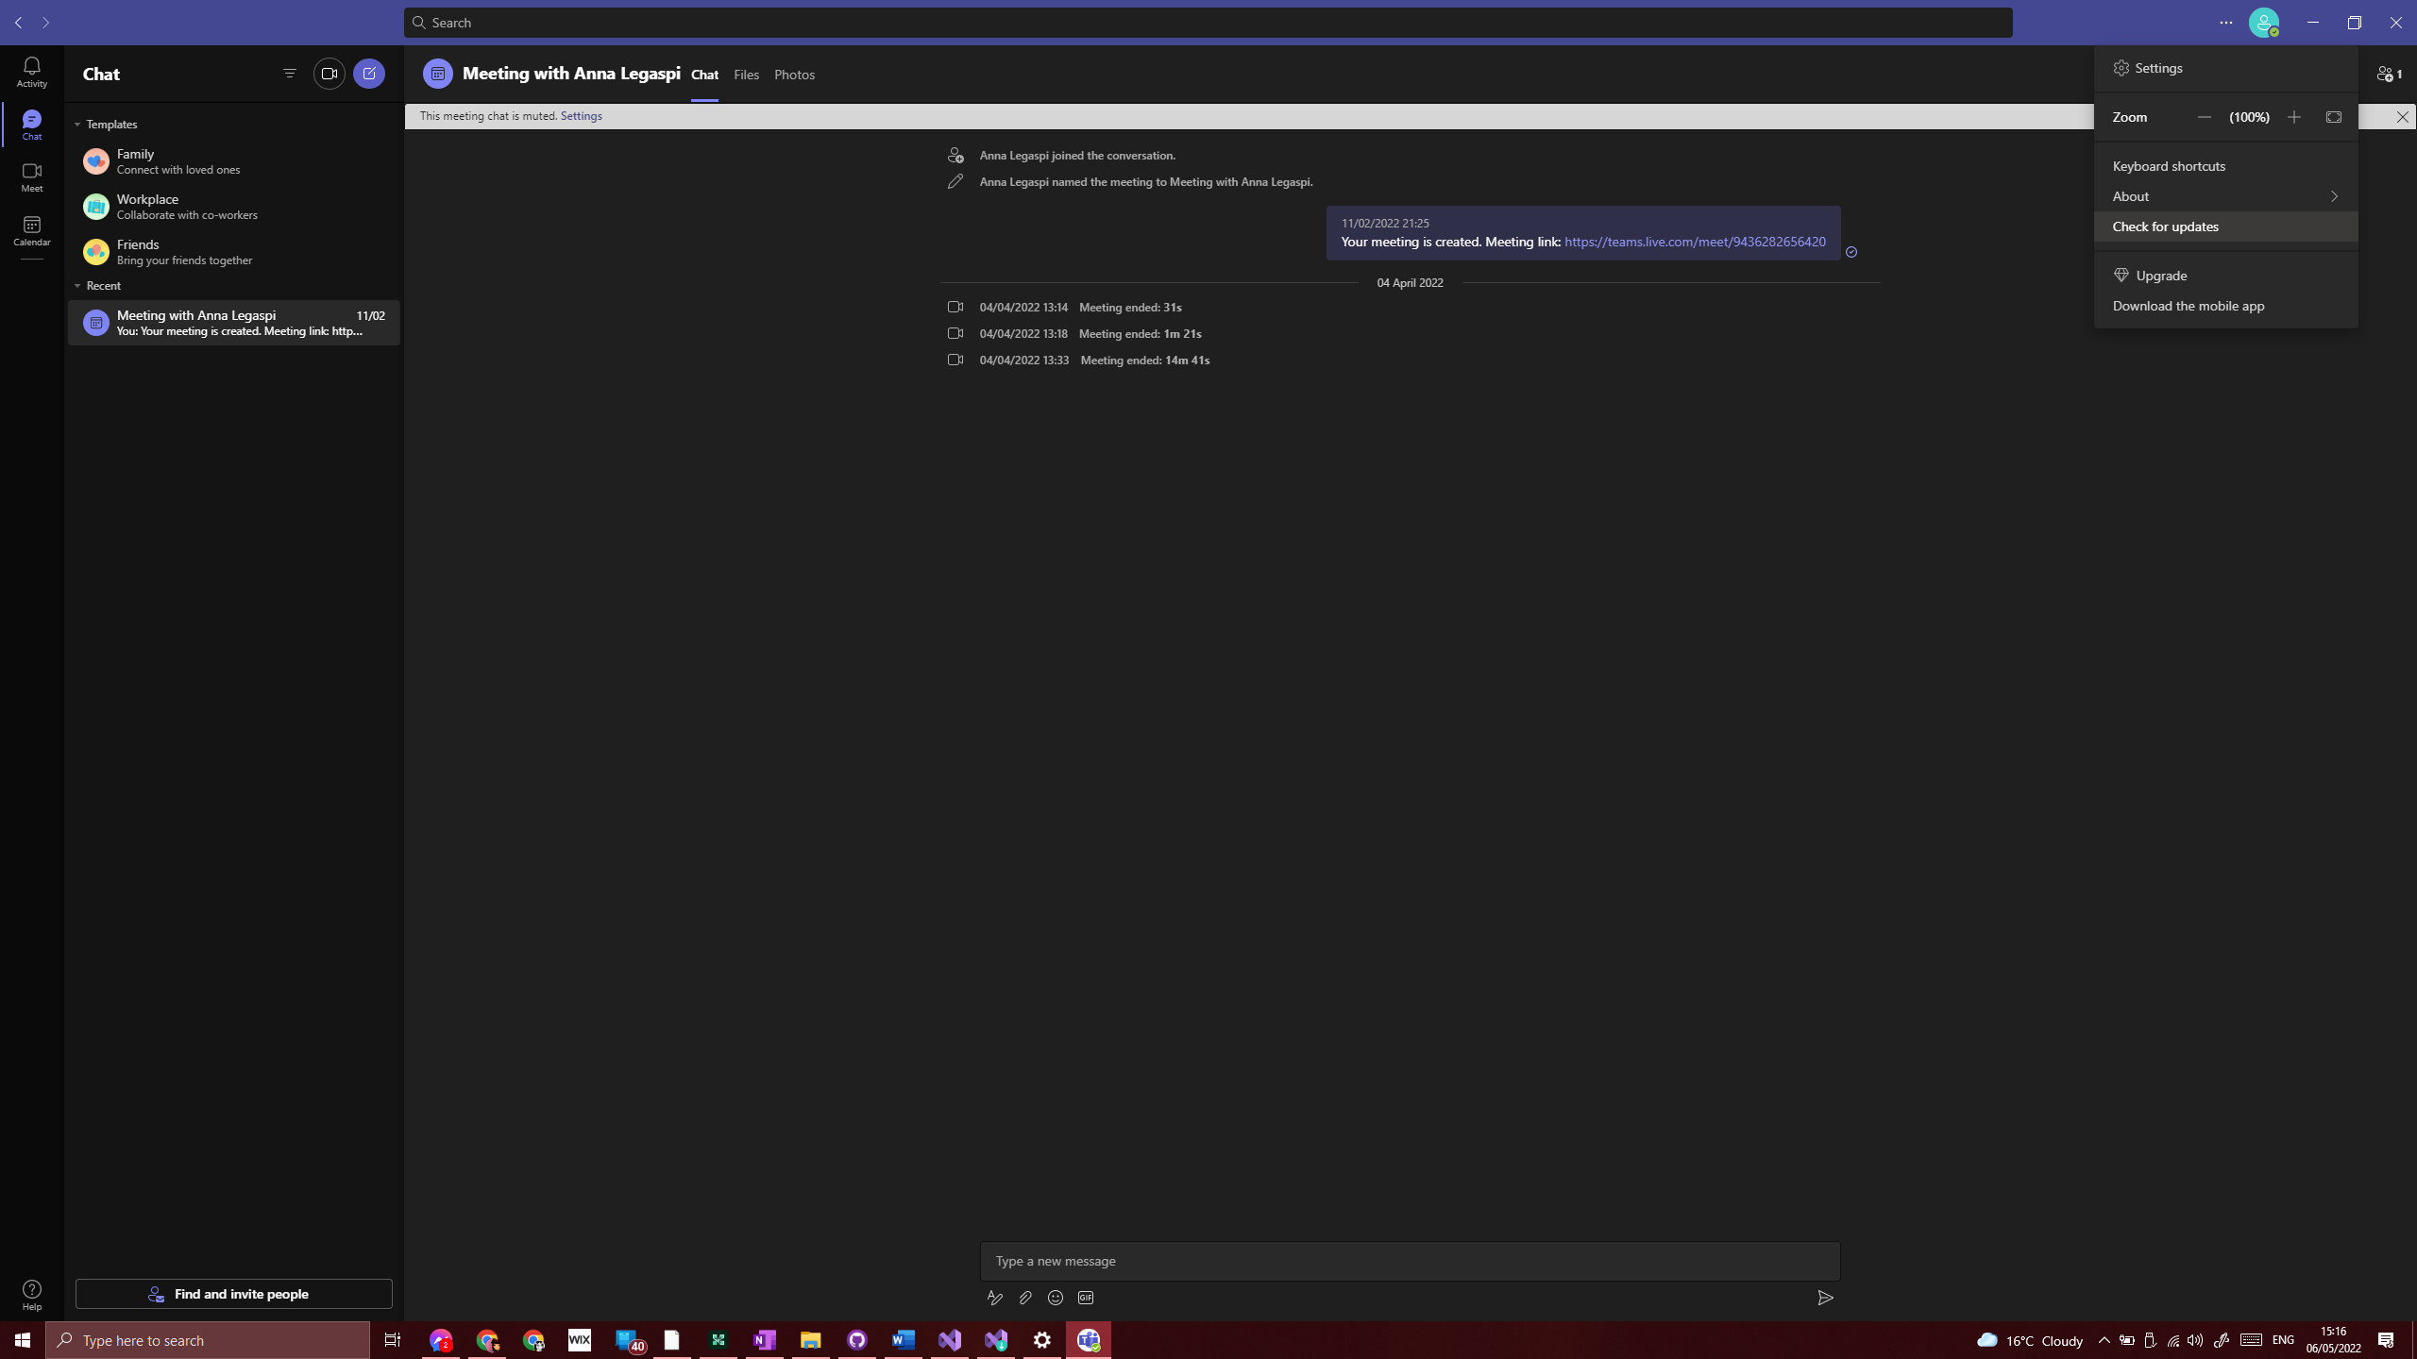



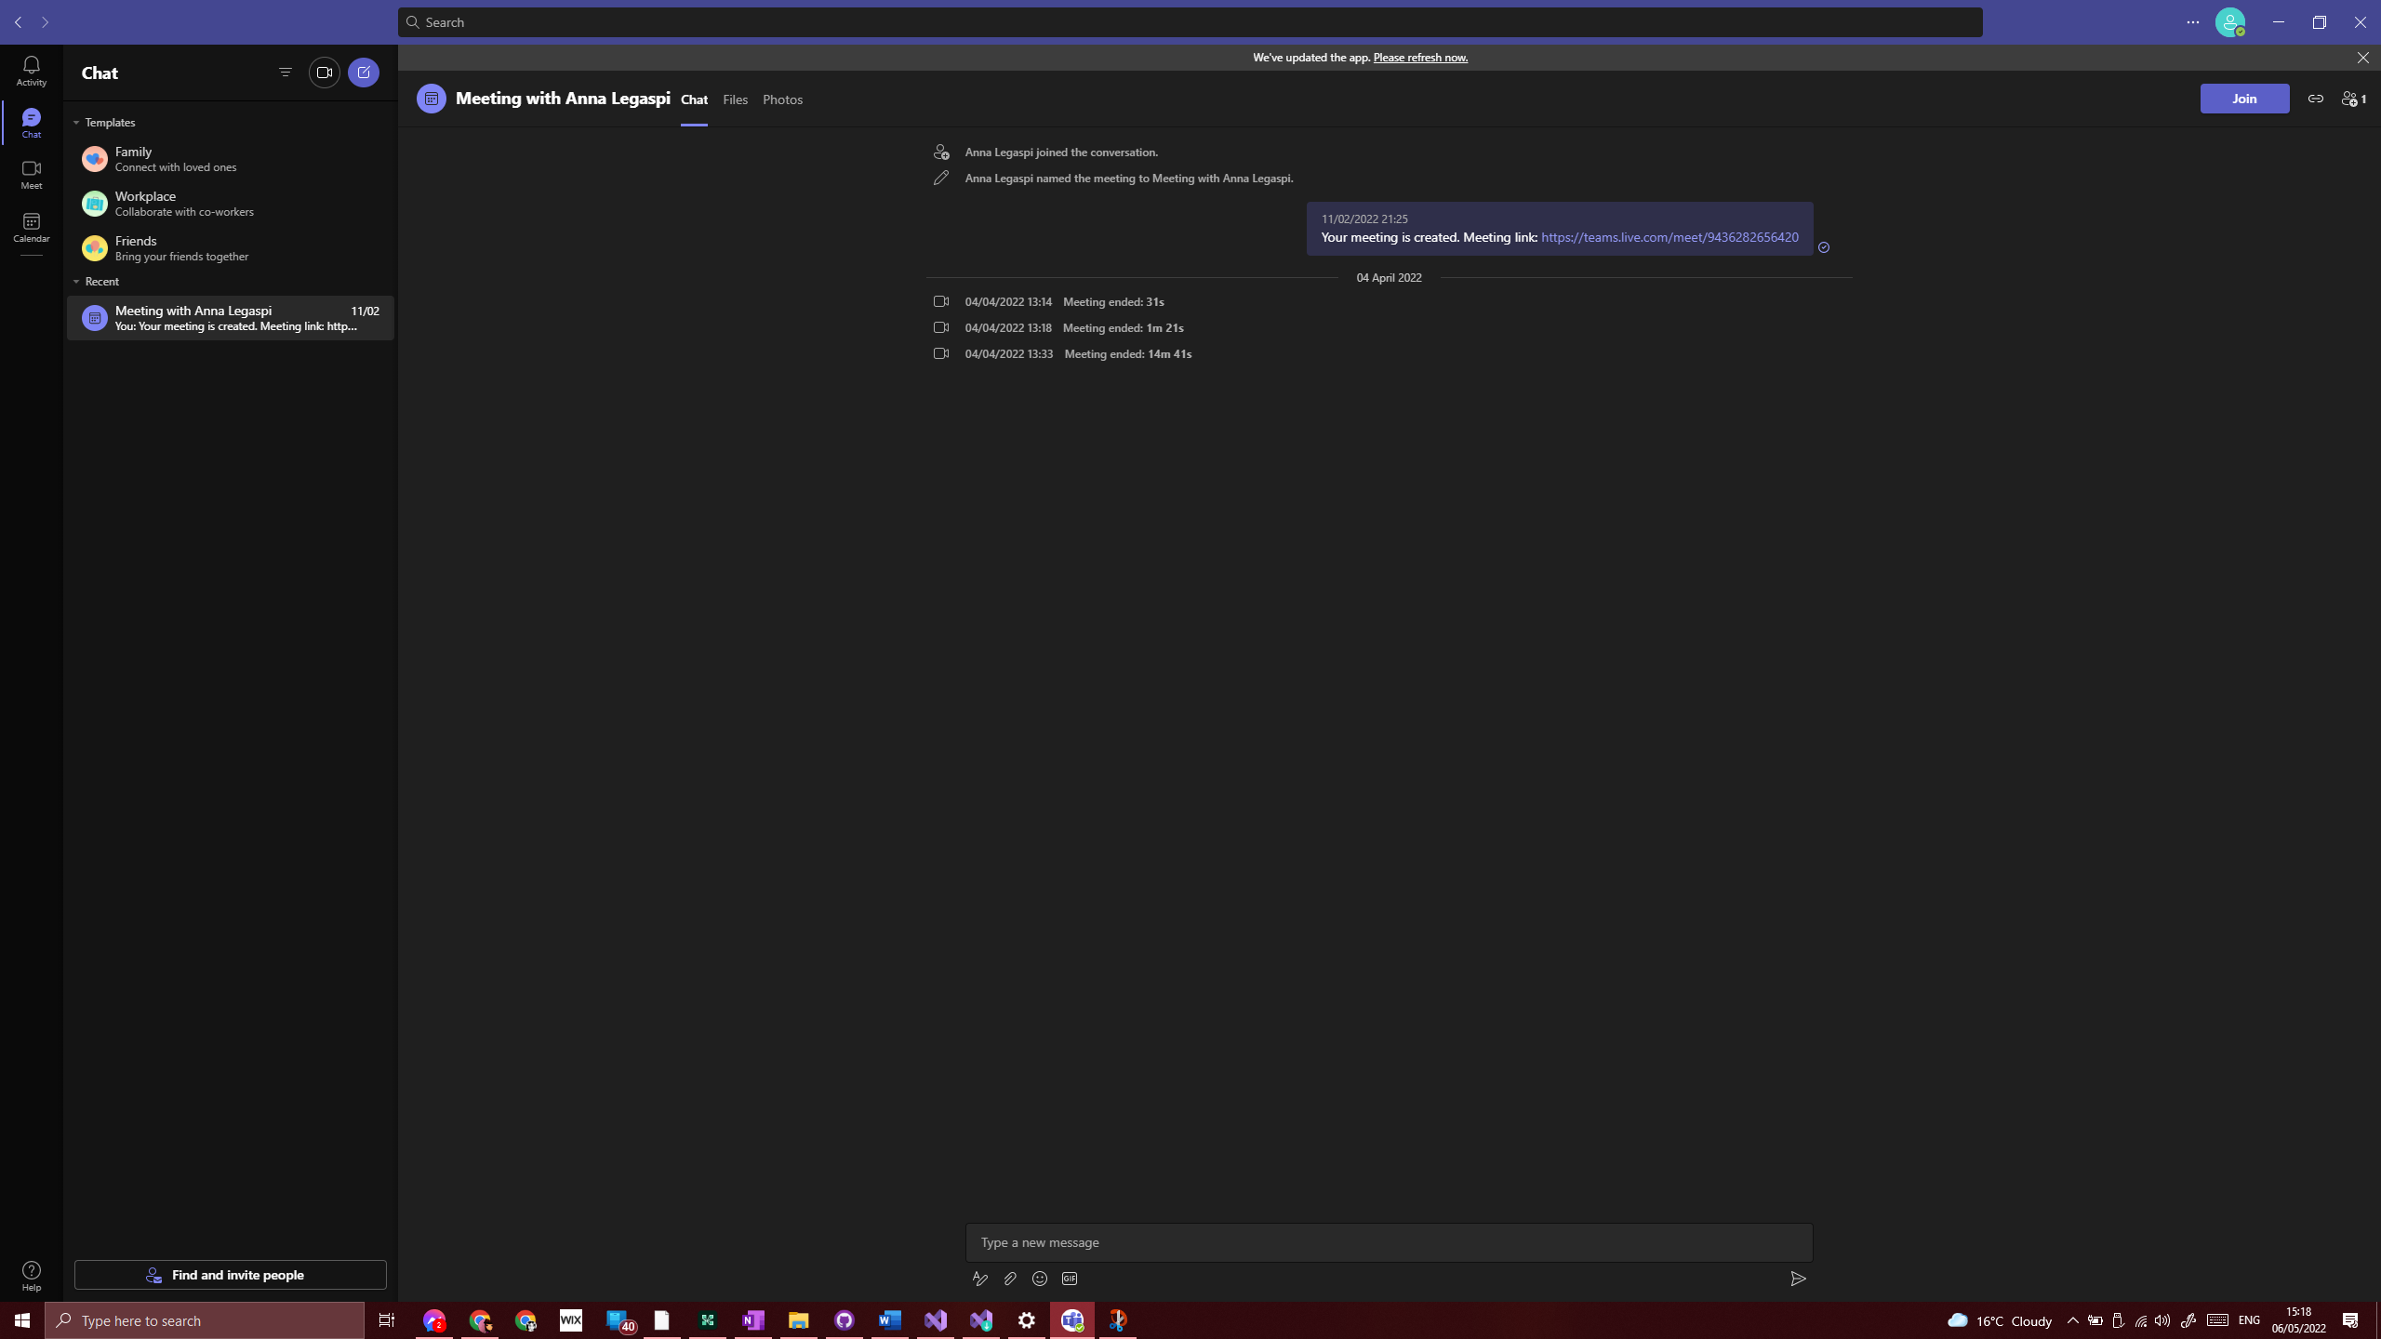



1. Check that the mic, speakers and camera are working. If not, do they work for other apps/software?

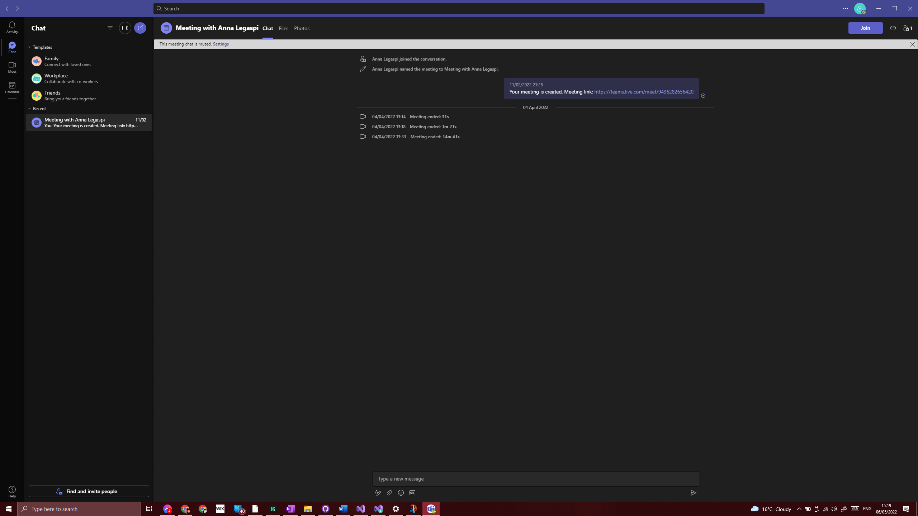



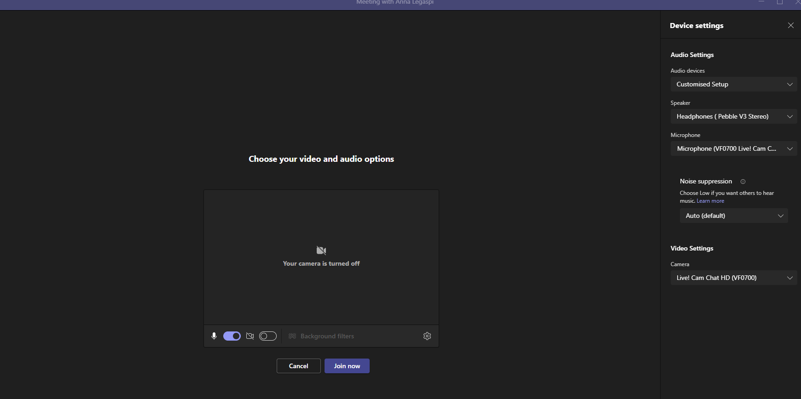

1. Check all drivers for camera, mic and speakers are up to date.
2. Restart Laptop/PC
3. Re-install application/software

If all the steps above still fail, then I would resolve to going online to find a solution to the problem. At this point, I will need to go to helpful forums or expert groups to find an answer. There are so many helpful and equally unhelpful advice online and the hard part is sifting through the hundreds, if not thousands of solutions people have uploaded online.

## Real life example

When we first downloaded Visual Studio, I followed the instructions provided by the tutor, but still had a few issues. I couldn’t do what Shafiq was asking me to do and was unsure how to make it work. To get this rectified, I had to check online for solutions.

I went on to Google and typed a variety of searches to try and find the answer. It was a bit of trial and error and opening the first few top results. I’ve searched using the following keyword combinations.

* asp.net web development visual studio
* asp.net web application not available visual studio 2022
* asp.net framework not available visual studio 2022

In the end, I found the answer on the website below.

<https://www.howtosolutions.net/2021/11/visual-studio-missing-asp-net-web-application-template-dotnet-framework/>

After implementing the advice provided by the website, which was to include specific individual components, the software started to work for me. In fact, I even emailed my tutor with the solution since a few learners were having problems. Unfortunately, I’ve since deleted the email so I’m unable to evidence this.

